**Data Manipulation Langauge**

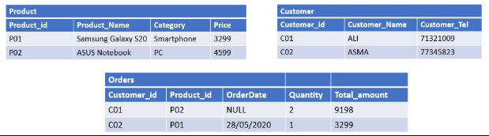

**INSERT** **INTO** Product **VALUES** (‘P01’, ‘Samsung Galaxy S20’, ‘Smartphone’, 3299) ;

**INSERT** **INTO** Product **VALUES** (‘P02’, ‘ASUS Notebook’, ‘PC’, 4599) ;

**INSERT** **INTO** Customer **VALUES** (‘C01’, ‘ALI’, 71321009) ;

**INSERT** **INTO** Customer **VALUES** (‘C02’, ‘ASMA’, 77345823) ;

**INSERT** **INTO** Orders (Customer_id, Product_id, Quantity, Total_amount) **VALUES** (‘C01’, ‘P02’, 2, 9198) ;

**INSERT** **INTO** Orders **VALUES** (‘C02’, ‘P01’, ‘28/05/2020’, 1, 3299) ;